1 | 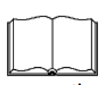 |  |  |  |  | Book |  |  |  |  | 7 | 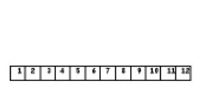 |  |  |  |  | Brush
 |  |  |  |  |  | Car |  |  |  |  |  |  |  |  |  |  | Pencil
 |  |  |  |  |  | Table |  |  |  |  |  |  |  |  |  |  | Pen
 |  |  |  |  |  | Cup |  |  |  |  |  |  |  |  |  |  | Ruler
2 | 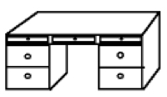 |  |  |  |  | Chair |  |  |  |  | 8 | 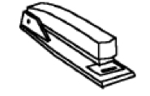 |  |  |  |  | Staple
 |  |  |  |  |  | Table |  |  |  |  |  |  |  |  |  |  | Stapler
 |  |  |  |  |  | Clock |  |  |  |  |  |  |  |  |  |  | Sharpener
 |  |  |  |  |  | Globe |  |  |  |  |  |  |  |  |  |  | Shoe
3 | 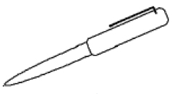 |  |  |  |  | Paper |  |  |  |  | 9 |  |  |  |  |  | Book
 |  |  |  |  |  | Scissors |  |  |  |  |  |  |  |  |  |  | Shelf
 |  |  |  |  |  | Pen |  |  |  |  |  |  |  |  |  |  | Globe
 |  |  |  |  |  | School |  |  |  |  |  |  |  |  |  |  | Table
4 | 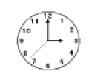 |  |  |  |  | Drawers |  |  |  |  | 10 | 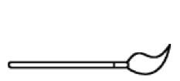 |  |  |  |  | Brush
 |  |  |  |  |  | Box |  |  |  |  |  |  |  |  |  |  | Pen
 |  |  |  |  |  | Book |  |  |  |  |  |  |  |  |  |  | Pencil
 |  |  |  |  |  | Clock |  |  |  |  |  |  |  |  |  |  | Ruler
5 | 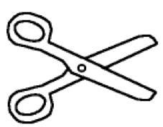 |  |  |  |  | Scissors |  |  |  |  | 11 | 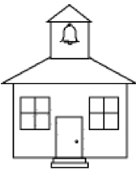 |  |  |  |  | School
 |  |  |  |  |  | Knife |  |  |  |  |  |  |  |  |  |  | Skyscraper
 |  |  |  |  |  | Fork |  |  |  |  |  |  |  |  |  |  | Sky
 |  |  |  |  |  | Saw |  |  |  |  |  |  |  |  |  |  | Football
6 | 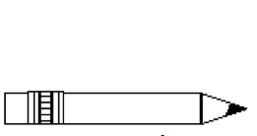 |  |  |  |  | Pencil |  |  |  |  | 12 | 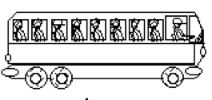 |  |  |  |  | Bus
 |  |  |  |  |  | Ruler |  |  |  |  |  |  |  |  |  |  | Car
 |  |  |  |  |  | Glue |  |  |  |  |  |  |  |  |  |  | Plane
 |  |  |  |  |  | Paper |  |  |  |  |  |  |  |  |  |  | Boat

 |  |  |  |  |  |  |  |  |  |  |  |  |  |  |  |  |  |  |  | CLASS
 | Name: |  |  |  |  |  |  |  |  |  |  |  |  |  |  |  |  |  | 1 |  |  | A
 |  |  |  |  |  |  |  |  |  |  |  |  |  |  |  |  |  |  | 2 |  |  | B
 |  |  |  |  |  |  |  |  |  |  |  |  |  |  |  |  |  |  | 3 |  |  | C
 |  |  |  |  |  |  |  |  |  |  |  |  |  |  |  |  |  |  | 4 |  |  | D
Lesson 1 - Unit 10A: At School  Shade in the correct word with the picture below |  |  |  |  |  |  |  |  |  |  |  |  |  |  |  |  |  |  | 5 |  |  | E
 |  |  |  |  |  |  |  |  |  |  |  |  |  |  |  |  |  |  | 6 |  |  | F

